# CDBM280 Assignment 1

Given: Sept 26, 2019

Due: Oct 3, 2019 10PM. No late submissions will be accepted.

## Part 1 - Create an ERD [35 marks]

Create an ERD for the following scenario:

1. The system to be modeled is a registry of animals.
   1. An animal has a date of birth, a name, and a fancy name. Each animal is assigned a ~~unique tag~~ with an id number that is used by the ~~registry~~ to identify that animal record. Each animal in the registry has a record of their sire and dam (these are their parent animals, meaning they are both other animal records in the registry).
      1. Animals belong to owners, though an animal may not have an owner listed if no one has owned them yet. An animal may, over the course of life, belong to several different owners – each ownership record has an ownership date.
      2. An animal belongs to a breed
      3. An animal is bred by a breeder (a breeder is not considered an owner)
   2. An owner has a name, one address, and one contact phone number.
   3. A breeder has a name, one address, and one contact phone number.
   4. A breed is a subset of a species. A breed has a name, developed year, and the region it was developed in (Think “German Shepherd” for example). A species has a common name (“Dog”, “Cat”) and a scientific name (“Canis Lupus Familiaris”, “Felis Catus”).
2. **Create a List of the questions and assumptions that you’ve made for the above problem. For instance, modalities not explicitly laid out in the problem definition should have an associated assumption and a *brief* explanation.**

## Part 2 Convert ERD to Relational Schema (15 marks)

Convert the ERD below into a relational schema. Provide a final schema. An ERD drawing is not your final solution to this part.

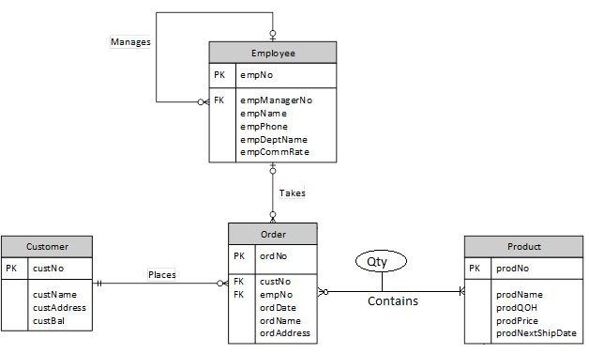

Quantity table

Need table between Order/Product

Quantity table

Quantity table needs quantityID, FK to both Order/Product

Split up custName, custAddress, ordAddress

No real reason to split up ordName, as the order doesn’t have a last or first name

Submission Instructions:

Submit a printed copy of your work to the CDBM280 drop box. Also submit an electronic copy to A:\CDBM280\A1. Name your document cst###a1.docx